EXP NO 12

1. AIM:To Design DFA using simulator to accept the input string “a” ,”ac”,and ”bac”.

Input:

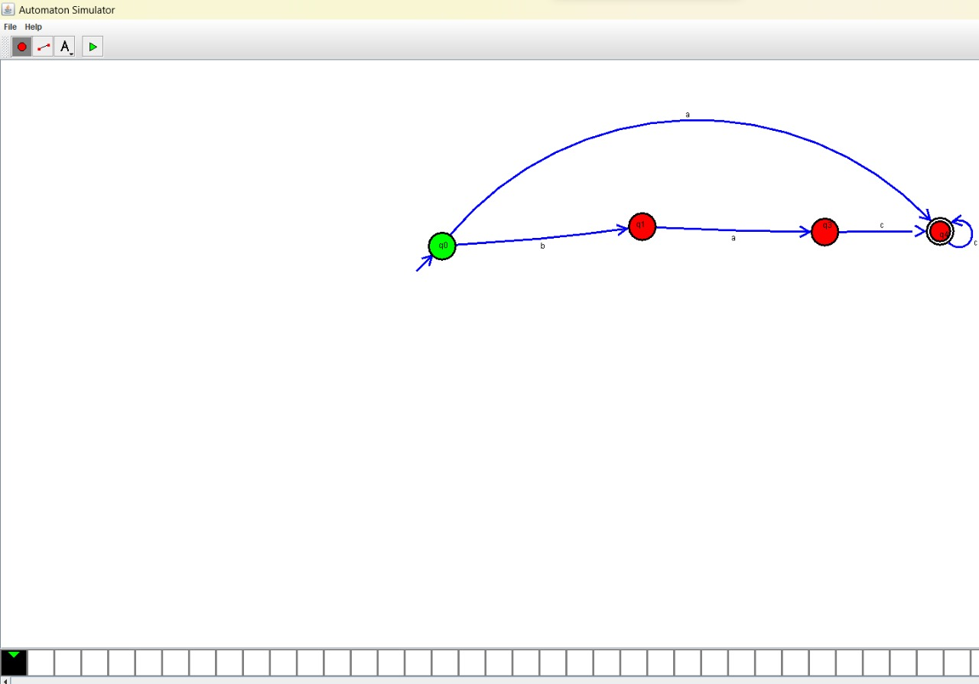

OUTPUT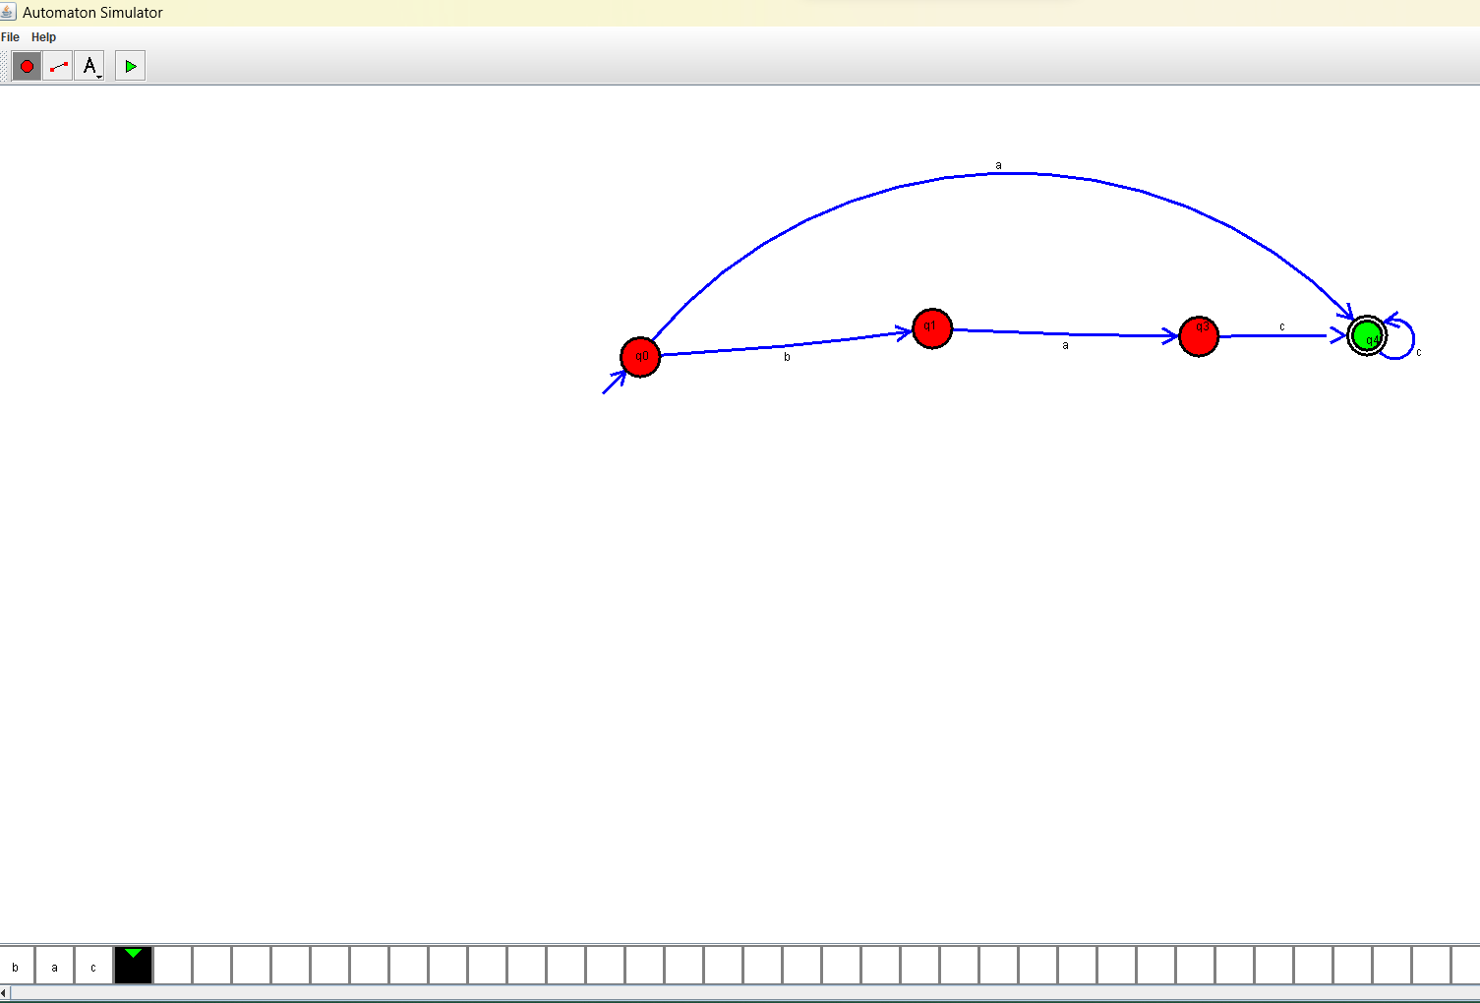

RESULT: **:** Hence, We designed a DFA using simulator to accept even number of “a”,”ac”,”bac”.